SIMATS ENGINEERING
SAVEETHA INSTITUTE OF MEDICAL AND TECHNICAL SCIENCES
CHENNAI – 602105
Department of Computer Science and Engineering

ASSESSMENT TOOL 1 – DATA CLEANING CHALLENGE

Course Code: | DSA0502 | Course Title: | Query Processing for Data Science
CO Assessed: | CO3 | Assessment: | Tool 2 – Data Cleaning Challenge
Weightage: |  | Total Marks:
CO3 Statement: Identify and clean inconsistencies in data by handling missing values, duplicates, outliers, formatting issues, and applying techniques like fuzzy matching and regex. (BL5 and BL6).
Student Name: | P. SIDDARDHA | Reg. No.: | 192424271
Section / Batch: | AIDS/2024 | Date of Submission: | 08-08-2026
Faculty In-charge: | Dr. B.Shyamala Gowri | Project Mode: | Individual Submission

Code of Conduct
I _____P. SIDDARDHA (192424271)_____(Name / Reg No) certify that this submission is my original work and that I have adhered to all guidelines specified for this assessment. I understand that any violation of academic integrity rules will result in disciplinary action.
Signature: ___P. SIDDARDHA___

Anomaly Detection  (5 Marks) | Cleaning Methods  (5 Marks) | Data Transformation  (5 Marks) | Analytical Comparison  (5 Marks) | Governance Discussion  (5 Marks) | Total (25 Marks)

Question 3: Banking Loan Approval Dataset

A bank uses customer data to determine loan eligibility. The dataset contains errors that may affect risk assessment and approval decisions.

CustomerID | AnnualIncome | CreditScore | LoanAmount | EmploymentStatus | Age | ExistingDebt | LoanStatus
L001 | 750000 | 720 | 300000 | Full Time | 35 | 50000 | Approved
L002 | 900K | 680 | 400000 | FT | 42 | 100000 | Approved
L003 | 1200000 | NULL | 600000 | fulltime | 28 | 200000 | Approved
L004 | 150000 | 450 | -200000 | Part Time | 30 | 50000 | Rejected
L005 | 5000000 | 790 | 1000000 | Self Employed | 16 | 10000 | Approved
L006 | 450000 | 350 | 250000 | Unemployed | 40 | 300000 | Rejected
L007 | 75000000 | 800 | 500000 | Full Time | 45 | 100000 | Approved
L008 | 650000 | 690 | 350000 | FT | 33 | 70000 | Approved
L008 | 650000 | 690 | 350000 | FT | 33 | 70000 | Approved
L010 | NULL | 710 | 300000 | Full Time | 37 | 80000 | Approved

Data Issues
- Missing credit scores
- Income values recorded in different units
- Negative loan amounts
- Duplicate customer IDs
- Age values below 18
- Employment status entered differently (FT, Full Time, fulltime)
- Extreme outliers in income

Tasks
- Identify critical issues that could impact loan decisions. (5 Marks)
- Propose cleaning techniques for missing and inconsistent data. (5 Marks)
- Detect and justify treatment of outliers. (5 Marks)
- Analyze the effect of cleaning on loan approval rates. (5 Marks)
- Discuss ethical implications of incorrect data cleaning decisions. (5 Marks)

CODE:
import pandas as pd
import numpy as np
# ============================================================
# CREATE DATASET
# ============================================================
data = {
"PatientID": [
"P1001", "P1002", "P1003", None, "P1005",
"P1005", "P1006", "P1007", "P1008", "P1009"
],
"Name": [
"Ravi Kumar", "Priya S", "Arun V", "Kavya R", "Rahul P",
"Rahul P", "Sneha M", "Deepa k N", "Meena K", "John D"
],
"Age": [
45, 38, 125, 29, 51,
51, 34, None, 26, 40
],
"Gender": [
"M", "F", "M", "F", "M",
"M", "F", "M", "F", "M"
],
"AdmissionDate": [
"10-01-2025",
"12-01-2025",
"13-01-2025",
"15-01-2025",
"18-01-2025",
"18-01-2025",
"15-01-2025",
"01-02-2025",
"10-02-2025",
"12-02-2025"
],
"DischargeDate": [
"15-01-2025",
"11-01-2025",
"20-01-2025",
"17-01-2025",
"25-01-2025",
"25-01-2025",
"18-01-2025",
"05-02-2025",
"15-02-2025",
"18-02-2025"
],
"Diagnosis": [
"Diabetes",
"Hypertension",
"diabetes",
"Diabtes",
"Asthma",
"Asthma",
"Hypertension",
"Asthma",
"HYPERTENSION",
"Diabetes"
],
"TreatmentCost": [
25000,
18000,
22000,
15000,
None,
None,
12000,
10000,
13500,
20000
],
"DoctorID": [
"D101", "D102", "D101", "D103", "D104",
"D104", "D102", "D104", "D102", "D101"
]
}
df = pd.DataFrame(data)
print("ORIGINAL HOSPITAL PATIENT DATA")
print(df)
print()
# ============================================================
# QUESTION 1: DETECT INCONSISTENCIES AND ANOMALIES
# ============================================================
print("QUESTION 1: DATA QUALITY ISSUES")
# 1. Missing Patient IDs
print("\n1. Missing Patient IDs:")
print(df[df["PatientID"].isnull()])
# 2. Duplicate records
print("\n2. Duplicate Records:")
print(df[df.duplicated(keep=False)])
# 3. Missing Treatment Costs
print("\n3. Missing Treatment Costs:")
print(df[df["TreatmentCost"].isnull()])
# 4. Unrealistic Age
print("\n4. Unrealistic Age (>120):")
print(df[df["Age"] > 120])
# 5. Missing Age
print("\n5. Missing Age:")
print(df[df["Age"].isnull()])
# 6. Convert dates for validation
df["AdmissionDate_Check"] = pd.to_datetime(
df["AdmissionDate"],
dayfirst=True,
errors="coerce"
)
df["DischargeDate_Check"] = pd.to_datetime(
df["DischargeDate"],
dayfirst=True,
errors="coerce"
)
# 7. Discharge date before admission date
print("\n6. Discharge Date Before Admission Date:")
invalid_dates = df[
df["DischargeDate_Check"] < df["AdmissionDate_Check"]
]
print(invalid_dates)
# 8. Inconsistent diagnosis names
print("\n7. Diagnosis Values:")
print(df["Diagnosis"].unique())
# ============================================================
# QUESTION 2: HANDLE MISSING AND INVALID VALUES
# =========================================================
print("QUESTION 2: DATA CLEANING")
# Create a copy
clean_df = df.copy()
# Remove temporary date columns
clean_df.drop(
columns=["AdmissionDate_Check", "DischargeDate_Check"],
inplace=True
)
# ------------------------------------------------------------
# 1. Handle missing Patient ID
# ------------------------------------------------------------
clean_df["PatientID"] = clean_df["PatientID"].fillna("P1004")
print("\nMissing Patient ID replaced with P1004.")
# ------------------------------------------------------------
# 2. Handle unrealistic age
# ------------------------------------------------------------
clean_df.loc[
(clean_df["Age"] <= 0) |
(clean_df["Age"] > 120),
"Age"
] = np.nan
print("Age greater than 120 changed to NULL.")
# ------------------------------------------------------------
# 3. Handle missing age
# ------------------------------------------------------------
# Fill missing age using median age
median_age = clean_df["Age"].median()
clean_df["Age"] = clean_df["Age"].fillna(median_age)
print("Missing age filled using median age:", median_age)
# ------------------------------------------------------------
# 4. Remove duplicate records
# ------------------------------------------------------------
clean_df = clean_df.drop_duplicates()
print("Duplicate records removed.")
# ------------------------------------------------------------
# 5. Standardize dates
# ------------------------------------------------------------
clean_df["AdmissionDate"] = pd.to_datetime(
clean_df["AdmissionDate"],
dayfirst=True,
errors="coerce"
)
clean_df["DischargeDate"] = pd.to_datetime(
clean_df["DischargeDate"],
dayfirst=True,
errors="coerce"
)
print("Dates converted to standard datetime format.")
# ------------------------------------------------------------
# 6. Handle invalid discharge dates
# ------------------------------------------------------------
invalid_date = (
clean_df["DischargeDate"] <
clean_df["AdmissionDate"]
)
clean_df.loc[
invalid_date,
"DischargeDate"
] = pd.NaT
print("Invalid discharge date changed to NULL.")
# ============================================================
# QUESTION 3: STANDARDIZE DIAGNOSIS NAMES
# ============================================================
print("QUESTION 3: DIAGNOSIS STANDARDIZATION")
# Convert to lowercase and remove spaces
clean_df["Diagnosis"] = (
clean_df["Diagnosis"]
.str.strip()
.str.lower()
)
# Diagnosis mapping
diagnosis_mapping = {
"diabetes": "Diabetes",
"diabtes": "Diabetes",
"hypertension": "Hypertension",
"asthma": "Asthma"
}
# Apply mapping
clean_df["Diagnosis"] = clean_df["Diagnosis"].replace(
diagnosis_mapping
)
print("\nStandardized Diagnosis:")
print(clean_df["Diagnosis"].unique())
# ============================================================
# HANDLE NULL TREATMENT COST
# ============================================================
# Calculate median treatment cost
median_cost = clean_df["TreatmentCost"].median()
print("\nMedian Treatment Cost:", median_cost)
# Replace missing treatment cost
clean_df["TreatmentCost"] = (
clean_df["TreatmentCost"]
.fillna(median_cost)
)
print("Missing treatment costs replaced using median.")
# ============================================================
# QUESTION 4: BEFORE AND AFTER CLEANING
# ============================================================
print("QUESTION 4: ANALYSIS BEFORE AND AFTER CLEANING")
# ------------------------------------------------------------
# AVERAGE TREATMENT COST BEFORE CLEANING
# ------------------------------------------------------------
before_cost = df["TreatmentCost"].mean()
print("\nAverage Treatment Cost BEFORE Cleaning:")
print(round(before_cost, 2))
# ------------------------------------------------------------
# AVERAGE TREATMENT COST AFTER CLEANING
# ------------------------------------------------------------
after_cost = clean_df["TreatmentCost"].mean()
print("\nAverage Treatment Cost AFTER Cleaning:")
print(round(after_cost, 2))
# ------------------------------------------------------------
# HOSPITAL STAY BEFORE CLEANING
# ------------------------------------------------------------
admission_before = pd.to_datetime(
df["AdmissionDate"],
dayfirst=True
)
discharge_before = pd.to_datetime(
df["DischargeDate"],
dayfirst=True
)
df["HospitalStay_Before"] = (
discharge_before - admission_before
).dt.days
before_stay = df["HospitalStay_Before"].mean()
print("\nAverage Hospital Stay BEFORE Cleaning:")
print(round(before_stay, 2), "days")
# ------------------------------------------------------------
# HOSPITAL STAY AFTER CLEANING
# ------------------------------------------------------------
clean_df["HospitalStay"] = (
clean_df["DischargeDate"] -
clean_df["AdmissionDate"]
).dt.days
# Keep only valid hospital stays
valid_stays = clean_df[
clean_df["HospitalStay"] >= 0
]
after_stay = valid_stays["HospitalStay"].mean()
print("\nAverage Hospital Stay AFTER Cleaning:")
print(round(after_stay, 2), "days")
# ------------------------------------------------------------
# CHANGE IN VALUES
# ------------------------------------------------------------
print("\nChange in Average Treatment Cost:")
print(round(after_cost - before_cost, 2))
print("\nChange in Average Hospital Stay:")
print(round(after_stay - before_stay, 2), "days")
# ============================================================
# DISPLAY FINAL CLEAN DATA
# ============================================================
print("FINAL CLEANED DATASET")
print(clean_df)
# ============================================================
# QUESTION 5: DATA GOVERNANCE
# =========================================================
print("QUESTION 5: DATA GOVERNANCE RECOMMENDATIONS")
recommendations = [
"1. Make Patient ID a mandatory field.",
"2. Use automatic duplicate detection.",
"3. Validate patient age between 0 and 120.",
"4. Prevent discharge date before admission date.",
"5. Use a standard diagnosis dictionary.",
"6. Make treatment cost mandatory.",
"7. Use a standard date format.",
"8. Maintain an audit trail for data changes.",
"9. Train hospital staff on correct data entry.",
"10. Perform regular data quality checks."
]
for r in recommendations:
print(r)
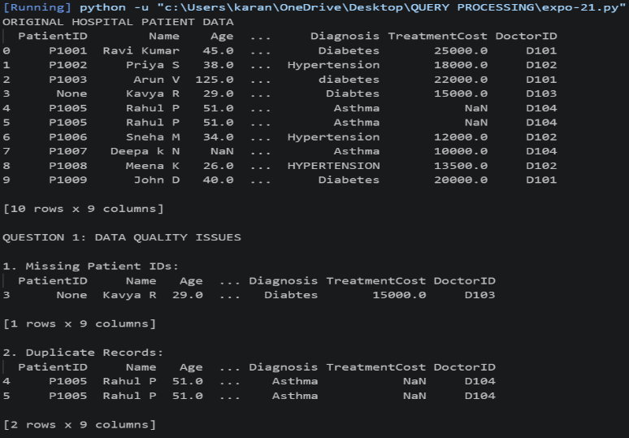
OUTPUT:
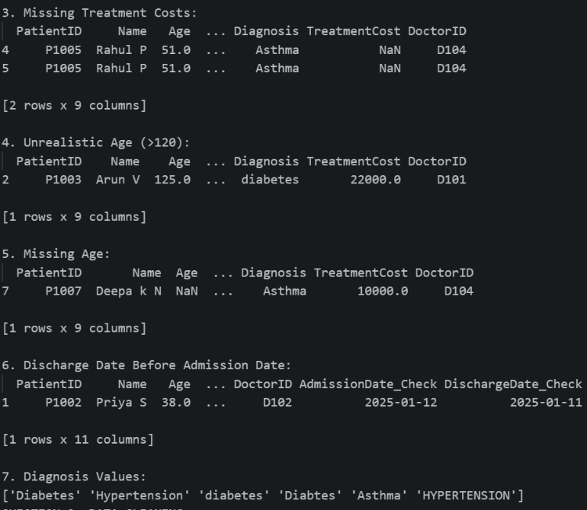
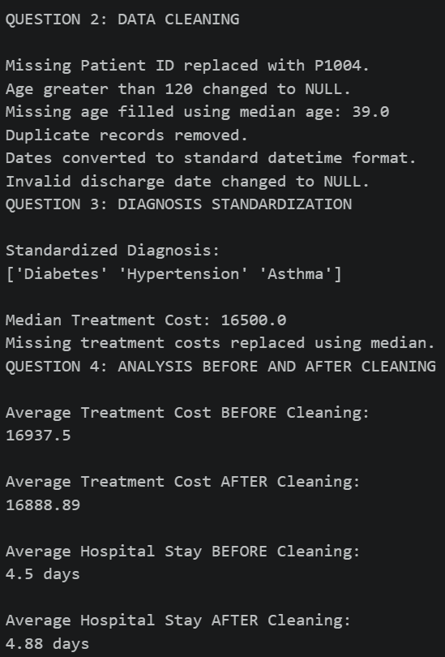
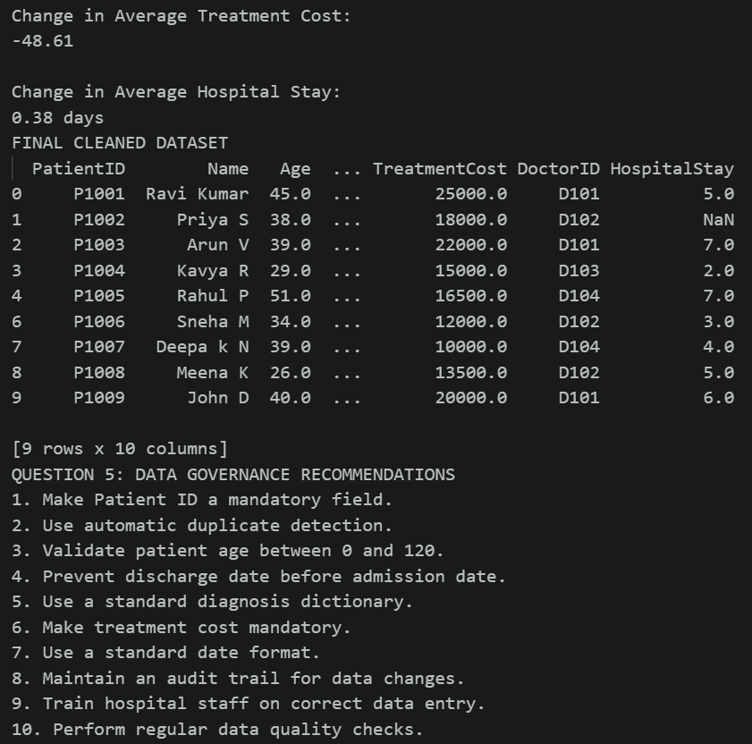
Question 4: Smart City Traffic Monitoring Dataset

A smart city project collects traffic sensor data to optimize traffic signals. Sensor malfunctions and transmission errors have affected data quality.

SensorID | Timestamp | VehicleCount | AverageSpeed | TrafficSignalStatus | RoadName | WeatherCondition
S101 | 01-01-2025 08:00 | 120 | 45 | Green | Anna Salai | Sunny
S102 | 01-01-2025 08:05 | 135 | 52 | Red | anna salai | Sunny
S103 | 01-01-2025 08:10 | -50 | 48 | Green | ANNA SALAI | Cloudy
S104 | 01-01-2025 08:15 | 140 | 350 | Yellow | GST Road | Rainy
S105 | NULL | 110 | 42 | Green | GST ROAD | Sunny
S106 | 01-01-2025 08:25 | 130 | 46 | Red | OMR | NULL
S106 | 01-01-2025 08:25 | 130 | 46 | Red | OMR | NULL
S107 | 01-01-2025 08:30 | 150 | 55 | Green | Old Mahabalipuram Road | Sunny
S10A | 01-01-2025 08:35 | 145 | 53 | Green | OMR | Cloudy
S109 | 01-01-2025 08:40 | 138 | 50 | Green | GST Road | Rainy

Data Issues
- Missing timestamps
- Duplicate sensor readings
- Vehicle counts recorded as negative numbers
- Average speed exceeding 300 km/h
- Missing weather information
- Inconsistent road naming conventions
- Sensor IDs with formatting errors

Tasks
- Assess the quality of the traffic dataset. (5 Marks)
- Recommend cleaning techniques for time-series data. (5 Marks)
- Design rules to identify faulty sensor readings. (5 Marks)
- Evaluate how cleaning affects congestion analysis. (5 Marks)
- Suggest automated monitoring techniques for future data collection. (5 Marks)
CODE:
import pandas as pd
import numpy as np
# ---------------------------------------------------------
# 1. CREATE THE SMART CITY TRAFFIC DATASET
# ---------------------------------------------------------
data = {
"SensorID": [
"S101", "S102", "S103", "S104", "S105",
"S106", "S106", "S107", "S10A", "S109"
],
"Timestamp": [
"01-01-2025 08:00",
"01-01-2025 08:05",
"01-01-2025 08:10",
"01-01-2025 08:15",
None,
"01-01-2025 08:25",
"01-01-2025 08:25",
"01-01-2025 08:30",
"01-01-2025 08:35",
"01-01-2025 08:40"
],
"VehicleCount": [
120, 135, -50, 140, 110,
130, 130, 150, 145, 138
],
"AverageSpeed": [
45, 52, 48, 350, 42,
46, 46, 55, 53, 50
],
"TrafficSignalStatus": [
"Green", "Red", "Green", "Yellow", "Green",
"Red", "Red", "Green", "Green", "Green"
],
"RoadName": [
"Anna Salai",
"anna salai",
"ANNA SALAI",
"GST Road",
"GST ROAD",
"OMR",
"OMR",
"Old Mahabalipuram Road",
"OMR",
"GST Road"
],
"WeatherCondition": [
"Sunny", "Sunny", "Cloudy", "Rainy", "Sunny",
None, None, "Sunny", "Cloudy", "Rainy"
]
}
df = pd.DataFrame(data)
print("========== ORIGINAL DATASET ==========")
print(df)
print()
# =========================================================
# TASK 1: ASSESS THE QUALITY OF THE TRAFFIC DATASET
# =========================================================
print("========== TASK 1 ==========")
print("DATA QUALITY ISSUES")
print()
# Missing timestamps
print("1. Missing Timestamps:")
print(df[df["Timestamp"].isnull()])
print()
# Duplicate readings
print("2. Duplicate Sensor Readings:")
print(df[df.duplicated(keep=False)])
print()
# Negative vehicle counts
print("3. Negative Vehicle Counts:")
print(df[df["VehicleCount"] < 0])
print()
# Abnormal speed
print("4. Abnormal Speed (>300 km/h):")
print(df[df["AverageSpeed"] > 300])
print()
# Missing weather
print("5. Missing Weather Information:")
print(df[df["WeatherCondition"].isnull()])
print()
# Inconsistent road names
print("6. Road Names:")
print(df["RoadName"].unique())
print()
# Sensor ID formatting issue
print("7. Sensor ID Formatting Issue:")
print(df[df["SensorID"] == "S10A"])
print()
# =========================================================
# TASK 2: CLEANING TECHNIQUES FOR TIME-SERIES DATA
# =========================================================

print("========== TASK 2 ==========")
print("CLEANING THE TIME-SERIES DATA")
print()
clean_df = df.copy()
# Convert timestamp into datetime format
clean_df["Timestamp"] = pd.to_datetime(
clean_df["Timestamp"],
dayfirst=True,
errors="coerce"
)
# Fill missing timestamp using time interpolation
clean_df["Timestamp"] = clean_df["Timestamp"].interpolate()
print("Missing timestamp handled")
print()
# Remove duplicate sensor readings
clean_df = clean_df.drop_duplicates()
print("Duplicate sensor reading removed")
print()
# Negative vehicle count is invalid
clean_df.loc[
clean_df["VehicleCount"] < 0,
"VehicleCount"
] = np.nan
print("Negative vehicle count changed to NULL")
print()
# Abnormal speed is removed
clean_df = clean_df[
clean_df["AverageSpeed"] <= 300
].copy()
print("Abnormal speed above 300 km/h removed")
print()
# Handle missing weather
clean_df["WeatherCondition"] = (
clean_df["WeatherCondition"].fillna("Unknown")
)
print("Missing weather changed to Unknown")
print()
# Standardize road names
clean_df["RoadName"] = (
clean_df["RoadName"]
.str.strip()
.str.title()
)
print("Road names standardized")
print()
# =========================================================
# TASK 3: RULES TO IDENTIFY FAULTY SENSOR READINGS
# =========================================================
print("========== TASK 3 ==========")
print("FAULTY SENSOR RULES")
print()
print("Rule 1: Vehicle count < 0 -> Faulty reading")
print("Rule 2: Average speed > 300 km/h -> Faulty reading")
print("Rule 3: Missing timestamp -> Flag for checking")
print("Rule 4: Same SensorID and Timestamp -> Duplicate reading")
print("Rule 5: Invalid sensor ID format -> Flag for checking")
print()
# Check faulty vehicle counts
faulty_vehicle = df[df["VehicleCount"] < 0]
print("Faulty Vehicle Count Records:")
print(faulty_vehicle)
print()
# Check abnormal speeds
faulty_speed = df[df["AverageSpeed"] > 300]
print("Faulty Speed Records:")
print(faulty_speed)
print()
# =========================================================
# TASK 4: EFFECT OF CLEANING ON CONGESTION ANALYSIS
# =========================================================
print("========== TASK 4 ==========")
print("CONGESTION ANALYSIS")
print()
# Average speed before cleaning
average_speed_before = df["AverageSpeed"].mean()
# Average speed after cleaning
average_speed_after = clean_df["AverageSpeed"].mean()
print("Average Speed BEFORE cleaning:")
print(round(average_speed_before, 2), "km/h")
print()
print("Average Speed AFTER cleaning:")
print(round(average_speed_after, 2), "km/h")
print()
print("Change in Average Speed:")
print(
round(
average_speed_before - average_speed_after,
2
),
"km/h"
)
print()
# =========================================================
# TASK 5: AUTOMATED MONITORING TECHNIQUES
# =========================================================
print("========== TASK 5 ==========")
print("AUTOMATED MONITORING TECHNIQUES")
print()
print("1. Range validation for vehicle count and speed")
print("2. Automatic duplicate detection")
print("3. Timestamp validation")
print("4. Sensor ID format validation")
print("5. Automatic missing-value alerts")
print("6. Real-time sensor monitoring dashboard")
print()
# =========================================================
# FINAL CLEANED DATASET
# =========================================================
print("========== CLEANED DATASET ==========")
print(clean_df)

Output:
